# ADAM FOOTBALL DB REPORT

# An introduction describing the web-app,

The web app I decided to develop is a database of some of my favourite football players.

From Lionel Messi to Ronaldinho, the web page contains the names, the clubs, the age, pitch position and overall-rating and nationality of each player in the database. My web app can come in handy to search players and get a quick review on the player’s stats. Of course the database is still primitive considering there is thousands of professional players and thousands of attributes for each one of them(eg. Fifa games). It is why the web page only focuses on my favourite players.

From the home page, you can see a preselection of players(see “Favourite players” in case you don’t know any, and maybe discover world class players playing in French, Spanish or English leagues.

In addition, under the “Favourite players” is a list of the last 5 players entered in the database, and updates automatically.

From the menu bar, there is 3 option available to you:

-display all players: displays all players entered in the txt database.

-display all clubs: Display all the clubs entered in the txt database

-video Gallery: A fun page where I posted 3 videos of amazing goals scored by the very best players in the world.

You can scroll through the available teams and players and select any for more details.

A specific page is automatically created for each player stats, following templates and fetches the data in the data.txt file(done in python).

# A design section explaining how you architected your web-app,

My web app is launched in python with my welcome.py code. Python is a great way to design app routes that call different templates in html.

Thanks to Jinja which is a featured template engine for python, templates can be extended which is great for inserting a headers and footers.

The database I am using right now is a text file, where all entities are separated with a “@”. This text file is then read line by line and data is extracted depending on the request.

Files are sorted in different directories. All html pages called through python are stored into a Template directory, the data in the text file is stored alongside the style.css into the Static directory. The python code is all stored into my welcome.py file which is stored at the same level as the “Static” and “Template” directories.

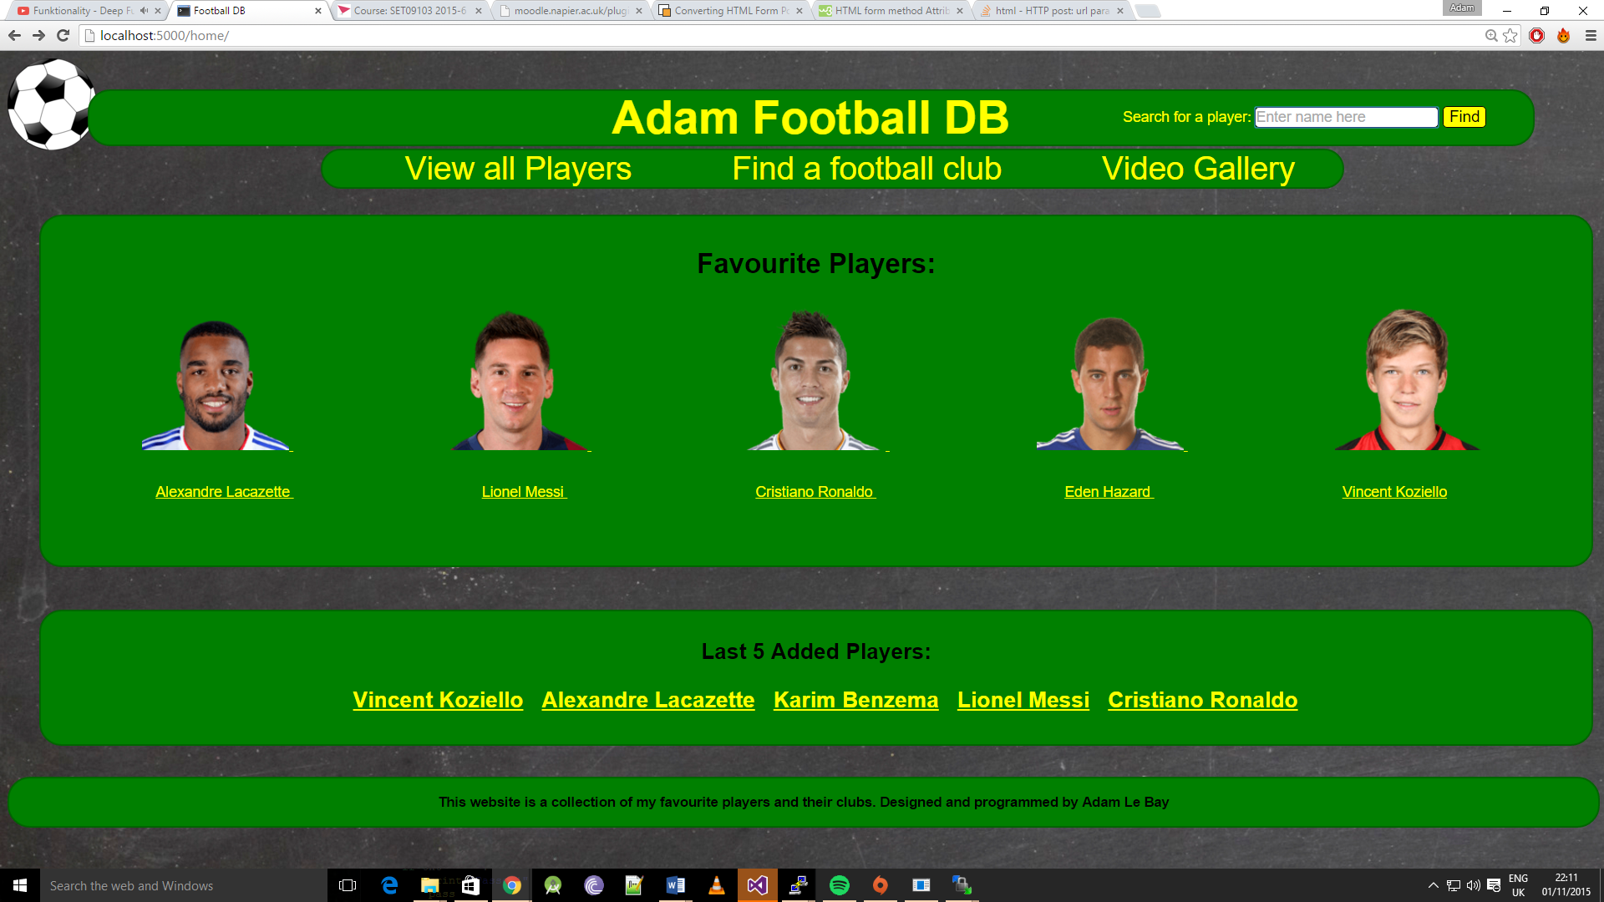

# An ‘enhancements’ section explaining what features you would add or improve

One feature that “Adam’s football DB’ lacks is a rating system, where users can comment, critic and rate the different players.

An average rating out of 10 points, would then be available depending on user’s review and rating. From that a “most popular” feature could be implemented.

Also the Search mechanism on Adam’s movies website is not real time responsive and does not support autocomplete which of course are some features that would improve user experience. This would ask some Jquery implementation.

Another feature that the website lacks, is the indicators (again done in Jquery) that indicates the user on which type of page he is (Players/Club/Galery). These indicator give the user a better understanding of how the website is constructed and where to find the information he is looking for.

Finally a last implementation the website lacks is a SQL database. For the long term using SQLlite3 would allow a better organization of data.

# A critical evaluation of your web-app

Unfortunately, Adam Football DB website does not support a true responsive design, even if most of the items are placed corresponding to the % width of the page. Making it responsive and usable on a smartphone would ask to considerably rethink most of the features and layouts. The menu should be redesigned implementing feature adapted to the screen (popular player page and recently added player page).

A huge limitation Adam s website has on its homepage is the “most popular films” “recently added” and “movie of the week” section that do not update automatically, as they are hardcoded. Popular movies should display depending on user ratings.

Finally, inserting data in the data.txt file isn’t the most efficient way. Adding a “Insert Data” option in my web-app would add a lot to the usability.

# A personal evaluation describing what you learned, the challenges you faced, and the methods you used to overcome them.

During my time coding the website I learnt a lot about python and jinja. I had already learnt css and html in web tech last year. This time , the challenge was to create a database.

Being used to use php, I found Flask and Jinja a lot more difficult to use.

Unfortunately I have not had the chance to try other languages (eg. Jquery ) that could have been implemented for better styling.

One of the biggest challenges I faced was the use of python, I had never used it for web development. Learning and understanding the logic was difficult.

# A summary of resources used and a list of references

Photos of players:

FUT database online (fifa 16 players) through their URL.

Data to populate data.txt:

<https://fr.wikipedia.org/wiki/Olympique_lyonnais>

<https://fr.wikipedia.org/wiki/Real_Madrid>

<https://fr.wikipedia.org/wiki/FC_Barcelona>

…

Icon and wallpaper

<http://muswellhillprimary.co.uk/wp-content/uploads/2015/03/free-football-clipart-4T9n9ArTE.png>

http://georgesrestaurant.com/wp-content/uploads/2010/07/Chalkboard.jpg

Learning

http://moodle.napier.ac.uk/pluginfile.php/955615/mod_resource/content/10/workbook.pdf

**jinja**.pocoo.org/

<http://stackoverflow.com/questions/3277503/python-read-file-line-by-line-into-array>

<http://www.tutorialspoint.com/python/file_readline.htm>

<http://www.w3schools.com/css/>

<http://tune.pk/video/2614478/introduction-to-python-web-development-with-levinux-and-bottlepy>

<http://stackoverflow.com/questions/4005327/http-post-url-parameters-and-form-data>